Project-HighLevelDesign

On

Automated Research Agent Report

Course Name: Data Analytics

Institution Name: Medicaps University – Datagami Skill Based Course

Sr no | Student Name | Enrolment Number
1. | KABIR KALANI | EN22CS301474
2. | KUNAL DHAKAD | EN22CS301534
3. | KARTIKEYA SINGH PARIHAR | EN22CS301490
4. | KHUSHI KARANJIYA | EN22CS301503
5. | KRATI AGRAWAL | EN22CS301513
6. | Kumar Saurav | EN22CS301531

Student Name(s) & Enrolment Number(s):
Group Name: Group 09D5
Project Number: AAI-09
Industry Mentor Name:
University Mentor Name:
Academic Year: 2026

Table of Contents
- Introduction
1.1 Scope of the Document
1.2 Intended Audience
1.3 System Overview
- System Design
2.1 Application Design
2.2 Process Flow
2.3 Information Flow
2.4 Components Design
2.5 Key Design Considerations
2.6 API Catalogue
- Data Design
3.1 Data Model
3.2 Data Access Mechanism
3.3 Data Retention Policies
3.4 Data Migration
- Interfaces
- State and Session Management
- Caching
- Non-Functional Requirements
7.1 Security Aspects
7.2 Performance Aspects
- References

1. Introduction
The rapid advancement of Artificial Intelligence and Large Language Models (LLMs) has enabled the development of intelligent systems capable of performing complex cognitive tasks autonomously. However, traditional search engines and static research tools often require manual filtering, summarization, and validation of information from multiple sources.
The Autonomous Technology Researcher Agent addresses this challenge by leveraging a multi-agent AI architecture powered by LangChain and CrewAI. The system autonomously interprets user research queries, performs web-based information retrieval, evaluates source credibility, synthesizes insights, and stores structured summaries into a knowledge repository.
Instead of a single monolithic chatbot, the system employs specialized agents collaborating under an orchestrator, ensuring modularity, scalability, reliability, and high-quality research output.
This document presents the High-Level Design (HLD) of the Autonomous Technology Researcher Agent, detailing architecture, workflows, data design, APIs, integration mechanisms, and non-functional requirements.

1.1 Scope of the Document
This document provides the High-Level Design (HLD) of the Autonomous Technology Researcher Agent.
The scope includes:
- Overall system architecture
- Multi-agent orchestration model
- Process and information flow
- Component-level design
- Data storage strategy
- API catalogue
- Session and state management
- Security and performance considerations
- Extensibility and scalability provisions

This HLD serves as a technical blueprint for developers, AI engineers, system architects, and academic evaluators.

1.2 Intended Audience
This document is intended for:
- AI/ML Engineers
- Backend Developers
- System Architects
- DevOps Engineers
- Technical Project Managers
- Academic Evaluators
It assumes familiarity with:
- Multi-agent systems
- REST APIs
- LLM orchestration
- Web search tools
- Python-based backend systems

1.3 System Overview
The Autonomous Technology Researcher Agent is an AI-powered research automation platform that:
- Accepts user technology-related research queries
- Breaks down complex queries into subtasks
- Performs autonomous web search
- Filters high-quality sources
- Synthesizes structured research summaries
- Persists results in a text-based knowledge repository
The system consists of:
- User Interface (CLI / Web API)
- CrewAI Orchestrator
- Planner Agent
- Research Agent
- Evaluator Agent

- Synthesizer Agent
- Tool Integration Layer (Search APIs & Web Scraping)
- LLM Interface
- Knowledge Repository

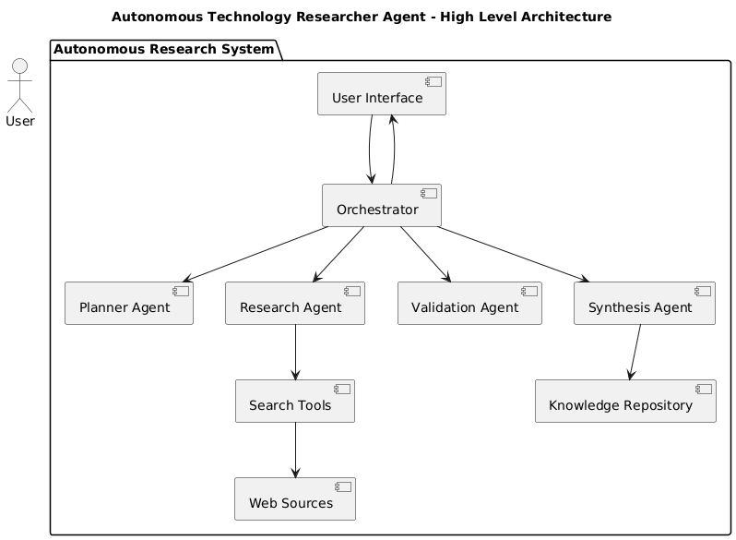

The architecture follows a layered, modular design ensuring separation of concerns and extensibility.

2. System Design
The system follows a Layered Multi-Agent Architecture to ensure scalability, reliability, and modular expansion.

2.1 Application Design
The application consists of the following modules:

User Interface Module
- Accepts research queries
- Displays structured research reports

Multi-Agent Orchestrator
- Coordinates agent execution
- Handles task dependencies
- Manages workflow lifecycle

Planner Agent
- Decomposes research query into subtask
- Defines search strategy

Research Agent
- Performs web search via APIs
- Extracts content from URLs
- Collects raw information

Evaluator Agent
- Validates source credibility
- Removes duplicate or low-quality data
- Prioritizes authoritative tech sources

Synthesizer Agent
- Summarizes findings
- Formats structured output
- Generates final research document

Knowledge Repository Module
- Persists generated summaries in text files
- Supports historical retrieval

2.2 Process Flow
The system workflow:
- User submits technology research query.
- UI forwards query to Orchestrator.
- Planner Agent creates research plan.
- Research Agent executes search tasks.
- Evaluator Agent filters and validates sources.
- Synthesizer Agent generates structured summary.
- Summary is saved to knowledge repository.
- Final output is returned to user.

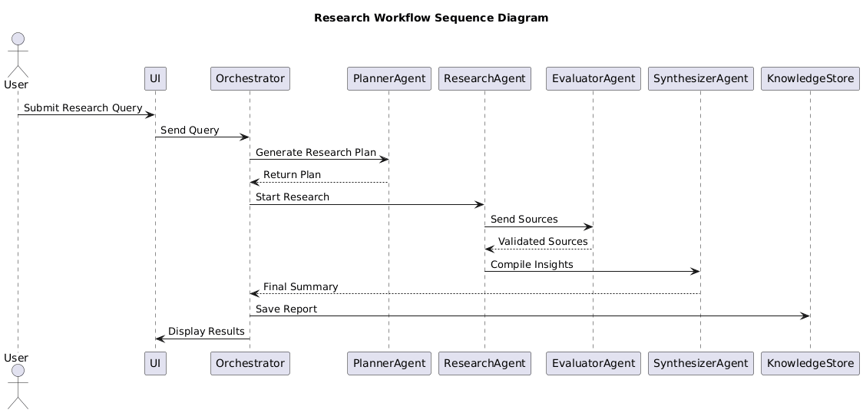

2.3 Information Flow
User Query
→ UI
→ Orchestrator
→ Planner Agent
→ Research Agent
→ Evaluator Agent
→ Synthesizer Agent
→ Knowledge Repository
→ User Interface
Each stage transforms and validates data before forwarding.

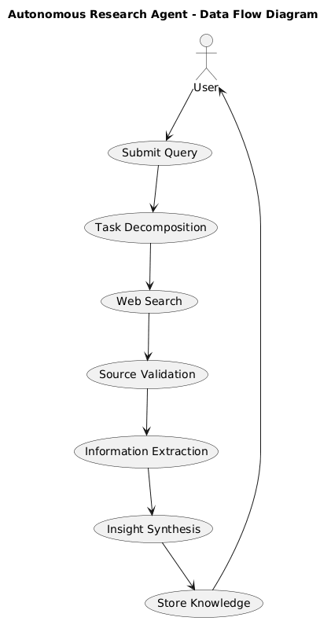

2.4 Components Design

Orchestrator Component
- Controls execution sequence
- Handles retries and failures
- Ensures structured agent collaboration

Agent Components
- Modular, role-based AI units
- Communicate via structured messages
- Use LLM reasoning internally

Tool Integration Component
- Connects to Search APIs (e.g., Tavily, SerpAPI)
- Web scraping utilities
- Content extraction modules

LLM Interface Component
- Connects to external LLM API
- Manages prompts and response formatting
- Enforces structured output

Persistence Component
- Stores summaries in Markdown/TXT format
- Optionally supports vector embedding storage
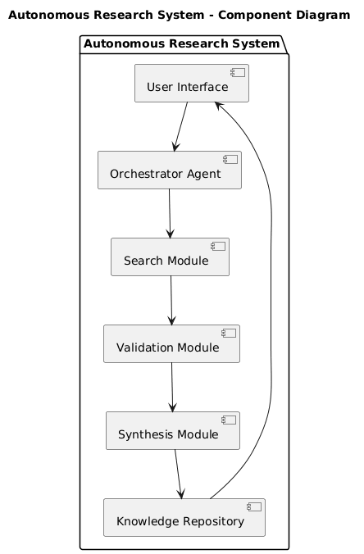

2.5 Key Design Considerations
- Modular multi-agent architecture
- Clear separation of responsibilities
- Autonomous tool usage capability
- Structured output enforcement
- Fault tolerance for API failures
- Extensibility for new research domains
- Reusability of stored knowledge

2.6 API Catalogue
Endpoint | Method | Description
/ | GET | Health check endpoint
/research | POST | Accepts research query and triggers multi-agent workflow
/reports | GET | Retrieves all stored research summaries
/report/{id} | GET | Retrieves specific research report
/session/start | POST | Initiates research session
/session/end | POST | Ends active session

3. Data Design

3.1 Data Model

Sessions
- session_id (Primary Key)
- start_time
- end_time
- context

Queries
- query_id (Primary Key)
- session_id (Foreign Key)
- user_input
- timestamp

Reports
- report_id (Primary Key)
- query_id (Foreign Key)
- summary_content
- sources
- generated_at

Knowledge_Files
- file_id
- title
- file_path
- created_at

3.2 Data Access Mechanism
- ORM-based interaction
- Indexed metadata fields
- Parameterized queries
- Transaction management
- File-based storage for summaries

3.3 Data Retention Policies
- Session logs stored temporarily

- Research reports retained indefinitely
- Source metadata retained for traceability
- Logs maintained for debugging

3.4 Data Migration
- Version-controlled schema updates
- Migration scripts
- Backup strategy
- Cloud-compatible architecture

4. Interfaces

4.1 External Interfaces

4.1.1 LLM Interface
The system integrates with external LLM APIs for reasoning, summarization, and structured generation.

4.1.2 Search API Interface
Enables real-time web research through search providers.

4.1.3 Web Scraping Interface
Extracts full content from URLs returned by search APIs.

4.2 Internal Interfaces

4.2.1 Orchestrator–Agent Interface
- Task delegation
- Structured message passing
- Error handling

4.2.2 Backend–Frontend Interface
- RESTful communication
- JSON-based request/response model
- Secure HTTP communication

5. State and Session Management
Short-Term State:
- Maintained during active session
- Stores recent queries and intermediate outputs
Long-Term State:
- Stored in database
- Enables historical report retrieval
Session Lifecycle:
Start → Active Research → Persist Report → End
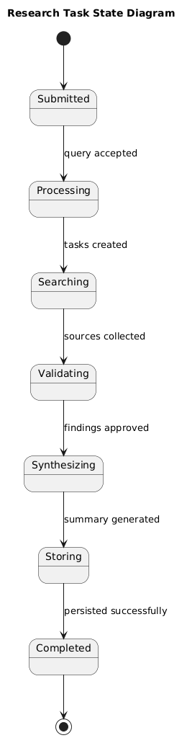

6. Caching
Current version:
- Minimal caching
Future enhancements:
- Redis-based caching
- Caching frequent research queries
- TTL expiration policy
- Reduced API call redundancy

7. Non-Functional Requirements

7.1 Security Aspects
- Secure API key management
- HTTPS communication
- Input sanitization
- Structured AI output enforcement
- Role-based database access
- Protection against prompt injection

7.2 Performance Aspects
- Asynchronous research execution
- Parallel agent tasks
- Optimized search queries
- Horizontal scalability support
- Efficient file storage handling

8. References
- LangChain Documentation – https://python.langchain.com/
- CrewAI Documentation – https://docs.crewai.com/
- FastAPI Documentation – https://fastapi.tiangolo.com/
- OpenAI API Documentation – https://platform.openai.com/docs
- Python Documentation – https://docs.python.org/

